**Course 4 overview**



Hello, and welcome to **Tools of the Trade: Linux and SQL**, the fourth course in the Google Cybersecurity Certificate. You're on an exciting journey!

By the end of this course, you will develop a greater understanding of the basics of computing that will support your work as a security analyst. You will learn foundational concepts related to understanding operating systems, communicating with the Linux operating system through commands, and querying databases with Structured Query Language (SQL). These are key concepts in the cybersecurity field and understanding them will help you keep organizations secure.

**Certificate program progress**

The Google Cybersecurity Certificate program has eight courses. **Tools of the Trade: Linux and SQL** is the fourth course.

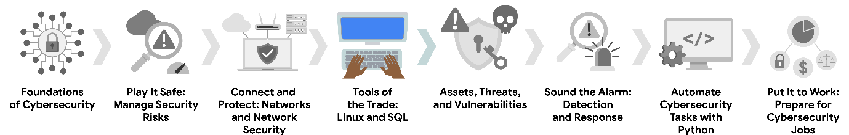

1. [**Foundations of Cybersecurity**](https://www.coursera.org/learn/foundations-of-cybersecurity/home/week/1)— Explore the cybersecurity profession, including significant events that led to the development of the cybersecurity field and its continued importance to organizational operations. Learn about entry-level cybersecurity roles and responsibilities.
2. [**Play It Safe: Manage Security Risks**](https://www.coursera.org/learn/manage-security-risks/home/week/1)— Identify how cybersecurity professionals use frameworks and controls to protect business operations, and explore common cybersecurity tools.
3. [**Connect and Protect: Networks and Network Security**](https://www.coursera.org/learn/networks-and-network-security/home/week/1)— Gain an understanding of network-level vulnerabilities and how to secure networks.
4. [**Tools of the Trade: Linux and SQL**](https://www.coursera.org/learn/linux-and-sql/home/week/1)— *(current course)* Explore foundational computing skills, including communicating with the Linux operating system through the command line and querying databases with SQL.
5. [**Assets, Threats, and Vulnerabilities**](https://www.coursera.org/learn/assets-threats-and-vulnerabilities/home/week/1)— Learn about the importance of security controls and developing a threat actor mindset to protect and defend an organization’s assets from various threats, risks, and vulnerabilities.
6. [**Sound the Alarm: Detection and Response**](https://www.coursera.org/learn/detection-and-response/home/week/1)— Understand the incident response lifecycle and practice using tools to detect and respond to cybersecurity incidents.
7. [**Automate Cybersecurity Tasks with Python**](https://www.coursera.org/learn/automate-cybersecurity-tasks-with-python/home/week/1)— Explore the Python programming language and write code to automate cybersecurity tasks.
8. [**Put It to Work: Prepare for Cybersecurity Jobs**](https://www.coursera.org/learn/prepare-for-cybersecurity-jobs/home/week/1)— Learn about incident classification, escalation, and ways to communicate with stakeholders. This course closes out the program with tips on how to engage with the cybersecurity community and prepare for your job search.

**Course 4 content**

Each course of this certificate program is broken into modules. You can complete courses at your own pace, but the module breakdowns are designed to help you finish the entire Google Cybersecurity Certificate in about six months.

What’s to come? Here’s a quick overview of the skills you’ll learn in each module of this course.

**Module 1: Introduction to operating systems**

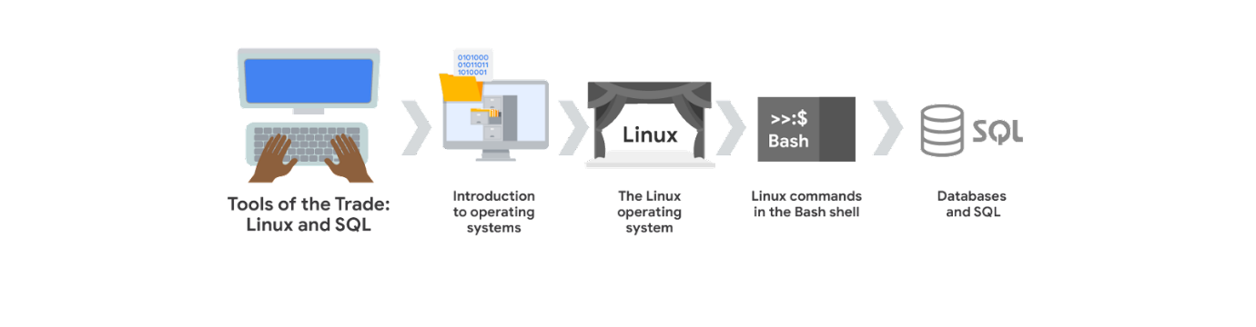

You will learn about the relationship between operating systems, hardware, and software, and become familiar with the primary functions of an operating system. You'll recognize common operating systems in use today and understand how the graphical user interface (GUI) and command-line interface (CLI) both allow users to interact with the operating system.

**Module 2:  The Linux operating system**

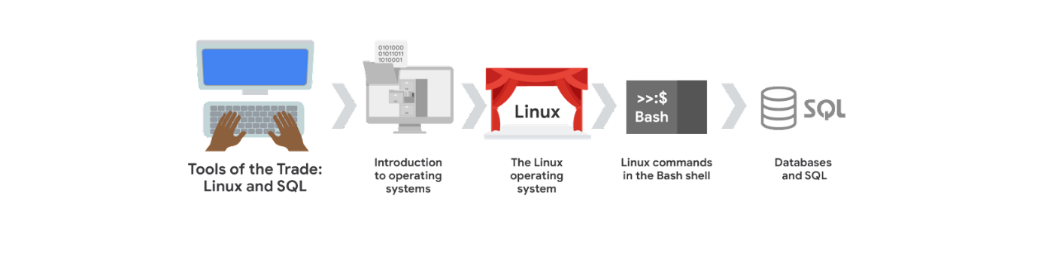

You will be introduced to the Linux operating system and learn how it is commonly used in cybersecurity. You’ll also learn about Linux architecture and common Linux distributions. In addition, you'll be introduced to the Linux shell and learn how it allows you to communicate with the operating system.

**Module 3: Linux commands in the Bash shell**

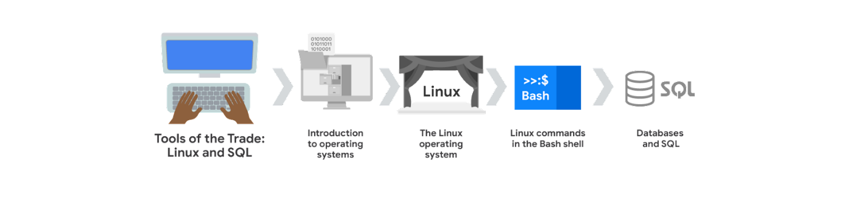

You will be introduced to Linux commands as entered through the Bash shell. You'll use the Bash shell to navigate and manage the file system and to authorize and authenticate users. You'll also learn where to go for help when working with new Linux commands.

**Module 4: Databases and SQL**

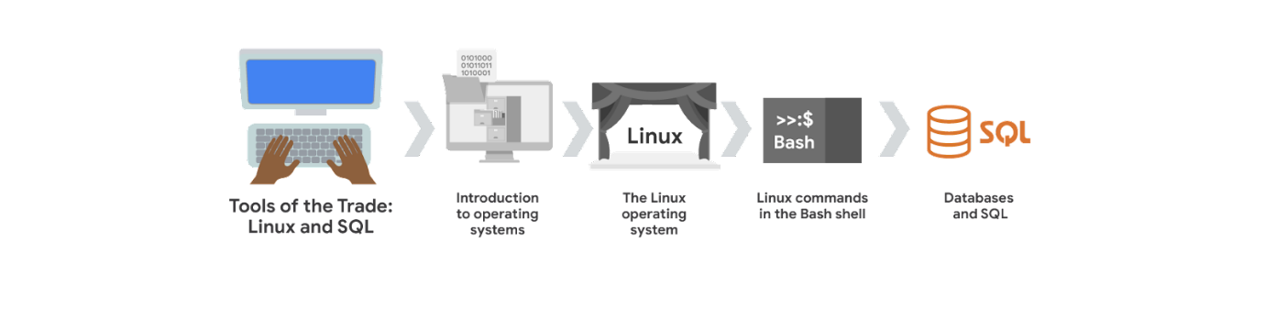

You will practice using SQL to communicate with databases. You'll learn how to query a database and filter the results. You’ll also learn how SQL can join multiple tables together in a query.

**What to expect**

Each course offers many types of learning opportunities:

* **Videos** led by Google instructors teach new concepts, introduce the use of relevant tools, offer career support, and provide inspirational personal stories.
* **Readings** build on the topics discussed in the videos, introduce related concepts, share useful resources, and describe case studies.
* **Discussion prompts** explore course topics for better understanding and allow you to chat and exchange ideas with other learners in the [discussion forums](https://www.coursera.org/learn/linux-and-sql/discussions).
* **Self-review activities** and **labs** give you hands-on practice in applying the skills you are learning and allow you to assess your own work by comparing it to a completed example.
* **Interactive plug-ins** encourage you to practice specific tasks and help you integrate knowledge you have gained in the course.
* **In-video quizzes** help you check your comprehension as you progress through each video.
* **Practice quizzes** allow you to check your understanding of key concepts and provide valuable feedback.
* **Graded quizzes** demonstrate your understanding of the main concepts of a course. You must score 80% or higher on each graded quiz to obtain a certificate, and you can take a graded quiz multiple times to achieve a passing score.

**Tips for success**

* It is strongly recommended that you go through the items in each lesson in the order they appear because new information and concepts build on previous knowledge.
* Participate in all learning opportunities to gain as much knowledge and experience as possible.
* If something is confusing, don’t hesitate to replay a video, review a reading, or repeat a self-review activity.
* Use the additional resources that are referenced in this course. They are designed to support your learning. You can find all of these resources in the [Resources](https://www.coursera.org/learn/linux-and-sql/resources/y7Px8) tab.
* When you encounter useful links in this course, bookmark them so you can refer to the information later for study or review.
* Understand and follow the [Coursera Code of Conduct](https://www.coursera.support/s/article/208280036-Coursera-Code-of-Conduct?) to ensure that the learning community remains a welcoming, friendly, and supportive place for all members.